

4-H Informant

### Pierce County 4-H Newsletter

**March-April, 2016**

Dear Family and Friends of Pierce County 4-H,

How many of your 4-H projects have you started this year? Mark Twain said,

“The secret of getting ahead is getting started.”

With all the activities in our busy schedules it is easy to put off our 4-H projects until summer, but starting now ensures that we have time to finish before fair time. Think through each 4-H project. Ask yourself:

1. What do I want to learn this year? In other words establish an educational goal.

2. Check for available resources. Consult with 4-H leaders in your club, as well as county leaders, other members, local resources, online resources, etc.

3. Put a plan together, either on paper or in your head.

4. Gather supplies and materials

5. Complete your project

6. Evaluate your result. What did you learn? What would you do differently?

7. Enter your project in the fair or display it at a 4-H Club meeting. Fair entries forms will be arriving soon.

**March/April 2016**

## Pierce County

Extension Office

Pierce County

Office Building

412 W. Kinne Street

P. O. Box 69

Ellsworth, WI

54011-0069

(715)-273-3531

Ext. 6663

Direct Line –

273-6781

Fax 273-6859

http://

pierce.uwex.edu

Wishing you the best in this 4-H year.

Sincerely,

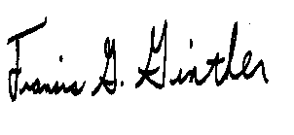

Eileen Van Dyk

Pierce County 4-H Program Assistant Frank Ginther

Pierce County 4-H Youth Development Agent

Amy VanDeBrake

Pierce County 4-H Program Advisor

**Pierce County UW Extension Staff**

Frank Ginther - 4-H Youth Development Agent Diana Alfuth – Horticulture Educator

Vacant – Agriculture Agent Katie Feuerhelm – Family Living Educator

Lori Zierl – Family Living Agent Eileen Van Dyk – 4-H Program Assistant

Sarah Johnson – Nutrition Educator Vacant-CNRED Agent

Amy VanDeBrake – 4-H Program Advisor & Sandy Radkey – Support Staff

Agriculture Educator JoAnna Demulling – Support Staff

4-H Family Calendar

**March**

14 NW 4-H Golf Classic Meeting

15,22, &29 NXT Mindstorm Robot Olympics

17 Sailers Meats 4-H Livestock Workshop, Elmwood

17,24,&31 WEDO Robotics

19 Performing Arts Festival, Spring Valley Elementary

19 Air Rifle and Air Pistol

20 Air Rifle and Air Pistol

20 4-H Foodstand Committee Meeting

21 VIP Training, River Falls Public Library

**25 Adult Advisors Scholarship and Key Award Due**

26 Beef Nutrition Workshop

31 Swine Learning Series 6:00-7:30 pm PCOB

**April**

**1 4-HHorse Project Fees DUE**

2 Foods Revue, Ellsworth High School

3 Rock Elm Skyrockets Dinner Theatre

3 Sheep Breeder’s Assoc. Annual Sale

6 Livestock Committee Meeting

9 Air Rifle and Air Pistol

10 Air Rifle and Air Pistol

10 Camp Counselor Training, Pepin High School

11 4-H Adult Advisors Council Meeting

**April Continued**

16 Air Rifle and Air Pistol

16 Sheep/Goal Weigh-In

16 Swine tagging day

17 Air Rifle and Air Pistol

17 Mandatory Dog Orientation Meeting

19 MAQA, Spring Valley High School

23 Younger Members Trip to Action City

23 SHOOT OFF for Air Rifle and Air pistol

24 Archery

28 Meat Goat Learning Series

30 Camp Kinnissippewa Registrations due (use 4hOnline)

**May**

1 Archery **and all 4-H Horse Project paperwork DUE**

7 Cloverbud/Explorer Day Camp

12 MAQA, River Falls High School

**June**

10-17 4-H Out of State Service Learning Trip to Oregon

13 NW 4-H Golf Classic Tournament, Kilkarney Hills RF

28-30 4-H Camp

**July**

11-15 4-H Gateway Academy, River Falls

4-H Club News

**Copies of the 4-H Informant/Newsletter**

If you would like the newsletter in a hard copy form regularly mailed to you, please call the Extension Office with your request and mailing address. Otherwise, the newsletter will sent out electronically via email for the remainder of the year except the “Fair Edition”. It is also available on our website: <http://pierce.uwex.edu/4-h-youth-development/4-h-informant-newsletter/>.

**Rain Barrels for Sale**

Contact the Extension Office about purchasing a rain barrel! They are great gifts for Mother’s Day, Father’s Day or a spring gift! The barrels cost $30 with proceeds benefitting Pierce County 4-H.

**The Rock Elm Skyrockets 4-H Club**

The Rock Elm Skyrockets 4-H Club, based in Elmwood, is holding a Dinner Theatre on April 3rd for our annual fundraiser. We are excited about this new adventure. As part of the evening's events, we would like to invite some of the clubs that are participating in the March 19 Performing Arts Festival at Spring Valley Elementary to show off their hard work! If you are interested in helping us out, please contact Mandy at [rockelm4h@yahoo.com](mailto:rockelm4h@yahoo.com) .

**4-H GOLF CLASSIC**



**Register now for the Annual 4-H Golf Tournament on Monday June 13, 2016 at Kilkarney Hills Golf Club. Registration fee includes: 18 hole green fees, golf cart, lunch and dinner. See the flyer/registration form at** [**http://pierce.uwex.edu**](http://pierce.uwex.edu)**.**

Under Youth Development find the registration form on the Upcoming Events page. Or call the UW Extension Office and one can be mailed to you.

Questions Contact Sharon Seibel 612-309-1794 or [Sharon@jsmachine.com](mailto:Sharon@jsmachine.com)

Fair News

**Fair Dates**

2016 – August 11-14th – “Going for the Gold at the Pierce County Fair”

**Fair Sign Program**

The fair sign program will be offered again for the 2016 Fair.  The Fair Office will be paying your club $25 for putting up a new sign and/or $10 for each previously used sign if the dates are changed to help promote the Pierce County Fair.  Max payment to club is $25 for one OR two sided new sign and max is $10 for updated one OR two sided sign. This is open to 4-H and FFA chapters.  Sign must be at least 4 feet by 8 feet (standard sheet of plywood) and include “Pierce County Fair”, “August 11-12-13-14”, “Ellsworth” and your club/chapter name.

**Century & Sesquicentennial Farms & Homes Wanted**

A farm or home (in whole or part) that has been in continuous family ownership are encouraged to complete an application to be recognized at the WI State Farm as well as this year’s Pierce County Fair. Farms & homes with 100 or 150 years of continuous ownership through the year 2016 are eligible. Contact the fair office or check out our web-site for more details. [www.co.pierce.wi.us/fair/fair_main.php](http://www.co.pierce.wi.us/fair/fair_main.php)

\*\***Remember to cash your Fair premium check from LAST YEAR if you haven’t already**

**FAIR ENTRY FORMS WILL BE OUT SOON!!!!!**

**The 4-H Office will soon be sending leaders a note saying your clubs fair entry forms are ready to be picked up. You should be able to get them at your April meeting. Your leader will give you the date they are due back to him/her, but will be by the end of May so get working on it right away!**

Adult Leaders

**Shooting Sports Leaders**

Three statewide Shooting Sports Leader Certification workshops will be held this spring on April 8-9, April 15-16 and April 29-30. Certification workshops are designed to teach leaders how to conduct safe, supervised, shooting experiences for 4-H members enrolled in shooting sports projects.

* [**Western Area Statewide Certification Workshop – April 8-9, 2016**](http://fyi.uwex.edu/wi4hshootingsports/events/western-area-certification-workshop/)  
  *Eau Claire Rod and Gun Club and Mouldy’s Archery Shop, Eau Claire* Disciplines: Archery, Pistol, Rifle and Shotgun; Registration deadline: March 26, 2016
* [**Eastern Area Statewide Certification Workshop – April 15-16, 2016**](http://fyi.uwex.edu/wi4hshootingsports/events/eastern-area-certification-workshop-2/)  
  *Brown County Extension Office, Green Bay and De Pere Sportsmen’s Club, De Pere* Disciplines: Archery, Rifle and Shotgun; Registration deadline: April 2, 2016
* [**Vernon Multi-County Statewide Certification Workshop – April 29-30, 2016**](http://fyi.uwex.edu/wi4hshootingsports/events/multi-county-statewide-certification-workshop/)  
  *Coon Valley Conservation Club, Coon Valley -* Disciplines: Archery, Coordinator, Muzzleloader, Rifle and Shotgun (Must have 4 in each class to offer a discipline); Registration deadline: April 15, 2016

**VIP Training**

Required Training for all New 4-H Volunteers (Formerly Youth Protection, now VIP)

All NEW Wisconsin 4-H volunteers will have to complete a “Mandated Reporter” training, done online, and come in for a “VIP Meeting” with their local 4-H Youth Development Agent (In Pierce County that is: Frank Ginther). Current volunteers who were up to date with “Youth Protection” as of last year do NOT have to do this – but please pass this along to your new club volunteers!

**Step One:** Enroll as an adult volunteer in 4hOnline.com, from your individual profile page or the profile page that your family already may have created, click on “trainings” (toward the top middle of the screen). It will take you to a new screen, click on “Sign Up for a Training” and follow the next screens through to take the Mandated Reporter online training.

**Step Two**: Sign up for one of the Volunteers in Preparation (VIP) Meetings with Frank. Please call/email ahead to sign up – at least by Noon the business day BEFORE the meeting to let us know you plan to attend. We need at least three people to hold the session. They are about an hour long, and will be offered the following dates if there are sufficient attendees:

* Monday, March 21st, River Falls Public Library – “Upper Lobby Meeting Room”

Contact the UW-Extension Office at 715-273-6781 or these e-mails to sign-up: [sandy.radkey@ces.uwex.edu](mailto:sandy.radkey@ces.uwex.edu) or [joanna.demulling@ces.uwex.edu](mailto:joanna.demulling@ces.uwex.edu). You may also contact 4-H Youth Development Agent Frank Ginther at [francis.ginther@ces.uwex.edu](mailto:francis.ginther@ces.uwex.edu) with questions or to arrange an individual VIP training meeting. Welcome to Wisconsin 4-H!! We’re glad to have your help!

**Understanding Your Adolescent**

Want to learn more about your adolescent? Check out this workshop which will explore: risky behavior, decision making, motivation, emotional regulation, focused attention, and respectful communication. The workshop will be held on the following dates:

* April 2nd, 9am - 12pm, Hudson Middle School
* April 9th, 9am - 12pm, Prescott Middle School
* April 16th, 9am - 12pm, Somerset Middle School
* April 30th, 9am - 12pm, Viking Middle School (Baldwin-Woodville)

Call the Pierce County Extension Office at 715-273-6781 for registration information or find it online at <http://pierce.uwex.edu>.

The presenter will be Brian Crim, LMFT. Registration and $5 fee is due 1 week prior to the event. Checks are made payable to “UW-Extension” and mailed to 412 W Kinne St, PO Box 69, Ellsworth, WI 54011.

**2016 Wisconsin Certified Pullorum Tester Training Seminar for Poultry**

A pullorum tester training seminar will be held on Thursday evening, April 7, 2016 from 6:00 p.m. – 8:00 p.m. at the Best Western Plover Hotel & Conference Center, located at 5253 Harding Ave., Plover, Wis. in their conference room. This seminar is for people who would like to become a certified pullorum tester for poultry in Wisconsin. Pre-registration is required. Space is limited to the first 80 people that register. Please contact Margie Proost by April 1, 2016 to register at 608-224-4877 or by email at margaret.proost@wisconsin.gov.

Older Members

**Older Member Trip**

We are in the initial stages of planning an older member trip/outing. If you have ideas for an older member trip, please contact the Extension Office. Possible ideas include: theatre, sporting events, recreation trips, ropes or challenge courses, give us your ideas. We will see what we can do.

**4-H International Still Seeking Host Families for the Summer**

4-H International is still looking for host families for summer hosting opportunities. We have 6 girls and 1 boy from Finland, and students from Costa Rica who will be in Wisconsin June 30 - July 23. Hosting is a wonderful way to learn about our world, and share your world with another country. These students only want to experience your daily life, be a part of your family & improve their English. This group is older teenagers, so we're looking for the high schoolers who might be willing to have someone tag along to all their events/activities. You only need to provide a bed/sleeping mat for the delegate, and their meals - it is adding 1 more to your family. Yes, everyone is super busy, but this isn't really too difficult or time consuming, and the rewards are great in learning and friendship.  
  
There will also be Japanese and Korean delegates coming July 24 - August 20th approximately. These are generally middle school aged, and again - same requirements to provide meals & a bed.    
  
You DO NOT have to travel or show them the entire state!! They want to learn about your family, way of life, and see how American families live.  Please consider applying for this great opportunity by going to <http://wi4hinternational.org> website to learn more & find all applications. For any questions, e mail [music_mommy@hotmail.com](mailto:music_mommy@hotmail.com) or call Nancy Burman at 715-549-6712.

**Pierce County Adult Advisors Scholarship**

Pierce County Adult Advisors will be awarding $400 scholarships to seniors in Pierce County. Criteria and application forms are available on our website: http://pierce.uwex.edu/ or stop by the office or call and we can mail one to you. Applications are due in the Extension Office on **March 25, 2016**. No late applications will be accepted.

**Pierce County 4-H Member Chosen for National 4-H Council PA Work**

Congratulations to Falcon Falls 4-H Club Member Mark Miller from River Falls.  Mark will be serving as a Program Assistant this summer at the National 4-H Center in Chevy Chase, Maryland.  He applied and was chosen to work with the Citizenship Washington Focus Program.  Mark is the third Pierce County 4-H member to receive this honor in the last 25 years.  Congratulations to Mark, have a great summer in our nation’s Capital!

Younger Members

**2016 Younger Member’s Trip Action City, Eau Claire Trip**

**(4th-7th Grade)**

Younger members in grades 4-7 mark your calendars for April 23 for a younger member trip to Action City in Eau Claire. The trip includes Indoor Go-Karts, Batting Cages, Climbing Wall, Bumper Cars, Laser Tag, Mini Bowling, Outdoor Maze, Outdoor Mini Golf, Outdoor Bandit Cars and Non-Ticket/Non-Redemption Video Arcade Games and a pizza buffet. We will have a 3 hour time span at Action City followed by the pizza buffet. We need a minimum of 20 participants for this trip so bring your friends for a fun filled day. **We will need adult chaperones for this event also!**

**Trip Schedule:**

**When**: Saturday, April 23

**Where:** Action City, Eau Claire

**Time:** Depart River Falls Shopko Parking Lot 8:30 AM

Depart Ellsworth Extension Office: 8:45 AM

**Arrive:** Action City, Eau Claire: 10:00 AM

Depart Eau Claire: 2:45 PM

Return to Ellsworth Extension Office: Approximately 4:00 pm

Return to River Falls Shopko Parking Lot: Approximately 4:15 pm

**Who**: Pierce County 4-H members 4th grade through 7th grade and non-4-H Friends

**Registration Due: Wednesday, April 13**

Pierce County Extension Office, 412 W. Kinne St, PO Box 69, Ellsworth, WI 54011

Please attach a signed copy of the Golden Rules with Registration.

**Cost:** $25 for any Pierce County 4-H Younger Member and $30 for a friend.

**You may want to bring extra money for Dairy Queen or to play ticket games at the Video Arcade.**

**Pierce County Younger Member Trip to Action City**

Name ______________________________________________________________________­__

Age ______________ Pick Up/Drop Off Location ____________________________________

Phone Number (Home) ____________________________________________________________

(Cell) ______________________________________________________________

Emergency Contact Name __________________________________________________________

Emergency Contact Number ________________________________________________________

Food Allergies/Health Issues _______________________________________________________

I would like to Parent Chaperone! Parent Name __________________________________________

Parent Chaperone Youth Protection Completed? __________________________________________

Parent Chaperone Cell Phone Number _________________________________________________

Amount Due: _______ $25 per Younger Member _______ $30 per Friend

Please make checks payable to: Pierce County 4-H

Send to: UW Extension Office, PO Box 69, Ellsworth WI 54011

**Cloverbud/Explorer Day Camp**

Cloverbuds and Explorer plan to attend our next Day Camp on Saturday, May 7th from 9:00 AM-Noon. We will be having a “Creepy, Crawly” experience. Watch for more information!

Robotics

**Robotics Workshops**

**CALLING ALL ROBOTICS PARTENTS:** We are in need of adult volunteers to help with robotics. No prior experience necessary, only a desire to learn and have fun. Contact [amy.vandebrake@ces.uwex.edu](mailto:amy.vandebrake@ces.uwex.edu) .

**Classes are Free BUT YOU MUST CALL TO REGISTER as classes are filling up. Space is limited. Sign up for any of these classes by calling the UW Extension Office at 715-273-6781. For much more information on all classes go to** <http://pierce.uwex.edu/> under 4-H or call the UW Extension Office at 715-273-6781 and info more info on each class can be sent or emailed to you.

* **NXT’s 105 NXT MINDSTORM 2.0 Robot Olympics March 15th, 22nd, 29th, 2016 (Grades 6-12)**
  + 6:00 p.m. – 8:00 p.m. at the Seyforth Bldg at the Pierce County Fair Grounds. Call the UW-Extension Office 715-273-6781 to register
* **WEDO Robotics 107 The Power of Technology and LEGO’s March 17th, 24th, & 31st (Grades 1-3)** 
  + **6:00 at Seyforth Bldg.**

**SOME CLASSES ARE ON WAIT LISTS ALREADY OR HAVE VERY LIMITED SPACE LEFT.**

**CALL TO RESERVE OR GET ON A WAITING LIST.**

Arts

**Performing Arts Festival**

**Where:** Spring Valley Elementary School, Spring Valley **When:** Saturday, March 19, 2016

**Who:** All 4-H Members and Cloverbuds

**Time:** Performances and judging will begin at 9 a.m. The end of the day will depend on the registration numbers. There will be two awards ceremonies, one during intermissions recognizing photography awards and individual music entries and the second awards ceremony will take place following the drama performances. Please remember that schedules are subject to change due to the pace of music performance rooms and on stage performances.

**What:** This festival includes all of the group on-stage performances (plays, skits, mini-dramas, and musicals), the individual music performances, and the small ensemble music performances, Pierce County’s Got Talent, Photography Judging and Life In Pierce County Photography Contest.

**Photography -** The Photography Festival and Life In Pierce County will be held at Spring Valley Elementary School, Spring Valley on the same day as the Performance Arts Festival Saturday, March 19, 2016. Please note photography judging will take place from 9:30 a.m.-11:30a.m.

**Camping Opportunities**

Wisconsin Youth Conservation Camp Opportunities are available for youth in northern Wisconsin and Upper Michigan. Contact the Extension Office for information.

Camp

**Applications for Camp Kinnissippewa 2016 are now open through your 4-H Online Account**

**Camp Kinnissippewa 4-H at Kiwanis Scout Camp**

MCj02308940000[1]



**3 different camp experiences for**

**4-H members from Buffalo, Pepin, Pierce, & Trempealeau Counties at the beautiful Camp Kiwanis at Marine on St. Croix River!**







## 4-H Base Camps: June 28-30, 2016

Enjoy an outdoor adventure at the 2016 4-H Base Camps. 4-H members will enjoy fellowship with new friends from Western Wisconsin while under the care of high school aged 4-H youth leaders who have been screened and trained. Campers will also have fun participating in teamwork activities with the staff of volunteers, summer interns, nurses and UW‑Extension 4-H Agents.

**Waterfront Information** (All campers are required to pass a swim test prior to using the pool or canoes.)

**4-H Explorers Base Camp**

**Open to campers in 3rd & 4th grades**

(2015-2016 school year)

*4-H Base Camp 1 features:*

* Arts & Crafts
* Nature Activities
* Music, Drama
* Interactive Games
* Swimming & Campfires
* Archery & Air Rifle
* Cabin Time to Make New Friends
* Lots of fun!

**4-H Navigators Base Camp**

**Open to campers in 5th & 6th grades**

(2015-2016 school year)

*4-H Base Camp 2 features:*

* Teambuilding Games
* Climbing Wall & Obstacle Course
* Variety of Team Sports
* Canoe Trip & Night Swim
* Archery & Air Rifle
* Special Campfires
* Extra Social Time to Meet New Friends
* Unique Leadership Activities!

## 4-H Outpost Adventurers Camp, June 28-30, 2016

**Open to campers in 7th & 8th grades (2015-2016 school year)**

Enjoy a ‘real’ camping adventure with the opportunity to experience nature and learn new skills related to the outdoors! There is plenty of time to engage in fellowship with teens from Western Wisconsin. Campers will also have fun participating in teamwork activities with the staff of volunteers, summer interns, nurses and UW‑Extension 4-H Agents. This will include overnights at William O’Brien State Park

*4-H Outpost Adventure features:*

* Canoe Trip Down St. Croix River
* Swimming at William O’Brien State Park
* Hiking & Hands on Learning
* Special Emphasis on Nature
* Leadership Building Experiences
* Two Nights in a Tent
* Orienteering
* Water Quality & Weather Science
* Teamwork Games & Social Time
* Outdoor Campfire Cooking!

***Health forms MUST be updated on 4-H online between June 1 and June 15, 2016***

#### 4-H Camp Transportation and Hours

Campers will need to arrive at camp by 1:00 p.m. on Tuesday, June 28th and will depart at 1:00 p.m. on Thursday, June 30th. Camp is located north of Stillwater, MN on Highway 95. Please choose your pick up and drop off location. Buses will be available to pick up campers in Ellsworth at the Pierce County Office Building, in Hudson at the Somerset Exit #4 on 94, and in Durand. Please note on the form if the camper will not need transportation and be taken to and picked up from camp by a parent.

**How to register for Camp Kinnissippewa**

### **Login to your** <https://wi.4hOnline.com> **account**

### **Forgot your email that you used for a user name? Call the UWEX Office, 715-273-6781**

### **Forgot your password? You reset it right from the login page – but you MUST know your email used as user name**

### **Go to your “My Member List”**

### **Scroll down the page**

### **Under “Register A Member In An Event”, select your child’s name from the dropdown box under “Member”, then select “4-H Camp Kinnissippewa”**

### **Under “Registration Types”, look to the right side and click on “Register”**

### **Fill out the form and continue through screens to register**

1. Please note - payment cannot be made online – you must submit the registration fee to the Pierce County UW-Extension Office within two weeks of online registration to confirm your child’s spot.
2. Checks can be made payable to “**Pierce County 4-H Adult Advisors**” and mailed to:

### **Pierce County UW-Extension Office**

### **412 West Kinne Street**

### **PO Box 69**

### **Ellsworth, WI 54011**

**A $10 late fee is assessed for 4-H camp registrations received after April 30, 2016.** The Pierce County 4-H Adult Advisors pays $20 for each camper who attends 4-H Camp Kinnissippewa. This amount has already been deducted from your 4-H Camp fees; the true cost of camp is $120 per camper.

**4-H Summer Camp Counselors STILL NEEDED!**

Hey 9th grade & older 4-H Members – Become a Camp Counselor this summer!! Deadline to sign up has been extended!! Camp dates are **June** **27-30, 2016** (Training & Camp)

April 10th is Counselor Training

**Benefits:** Receive unique opportunity for personal and organizational leadership development, all training materials,

camp sweatshirt, camp lanyard, camp drawstring backpack, and all meals and lodging at 4-H Camp.

**Application Fee:** Waived at time of application for Pierce County 4-H Camp Kinnissippewa Counselor Staff through a State Farm grant

**Application Procedure and Deadline:** Send 4-H Camp Kinnissippewa Application along with a cover letter. Call 715-273-6781 to have an application emailed to you or find the form on our website: <http://pierce.uwex.edu/>

Due March 31 to:

**Pierce County UW-Extension, PO BOX 69, Ellsworth, WI 54011** Email: [francis.ginther@ces.uwex.edu](mailto:francis.ginther@ces.uwex.edu)

Livestock

**Important Livestock Dates**

**Livestock Learning Series Meetings, 6-7:30pm in the Pierce County Extension Office Meeting Room**

* March 31, Swine
* April 28, Meat Goats

**Other livestock dates:**

* Livestock Committee meeting, Wednesday, April 6, 2016
* 2016 Swine Exhibitors : Swine tagging day will be on April 16th
* Sheep and Goat Weigh-In- is April 16th 2016
* Sheep Breeders Assoc.Annual Sheep Sale- UWRF Mann Valley Farm- April 3, 2016, [chanson@sdwi.org](mailto:chanson@sdwi.org)
* Block and Bridle Show, April 30 and May 1, 2016, Pierce County Fairgrounds
* Dust ‘Em Off Livestock Show, June 4, St. Croix County Fairgrounds, Glenwood City
* Area Animal Science Days, June 30, 2016 St. Croix County Fairgrounds, Glenwood City
* Interstate Livestock Show, June 19, 2016 Polk County Fairgrounds, St. Croix Falls, WI

**Livestock Judging – Join the Pierce County Teams!**

2016 marks the start for new opportunities for Pierce County 4-H/ FFA livestock project members. In past participation in Area Animal Science Days, Agriculture Technology Contests, and other educational workshops related to livestock, youth have been asking, when are livestock judging practices going to start for the new 2016 judging year? Any youth who are in grades 3-13 who have an interest in animal agriculture and its related industries are encouraged to participate in Livestock Judging. By participating in livestock judging youth will have the opportunity to travel and visit a diversity of beef, swine, lamb and goat farming operations within Pierce County and travel throughout the state to view and judge animals from top producing herds. Youth will meet and interact with the owners and managers of these successful operations, and these contacts can help youth better understand animal agriculture and develop stronger ties with its leaders. For more information regarding practice times and schedules please contact Baily Sherwin at 715-307-3412 or the UWEX office at 715-274-6781.

**ALL SPECIES EDUCATION WORKSHOP: SAILER’S MEATS**

Reminder - The Pierce County Livestock Committee is partnering with Sailer’s Food Market & Meat Processing Plant on **March 17th, 2016 at 6:00 p.m**. to host an all species educational workshop related to livestock meat processing and evaluation. Sailer’s Food Market & Meat Processing Plant is located at : 600 W Winter Ave, Elmwood, WI 54740. Sailer’s is a 5th generation meats processing facility and has supported the Pierce County Fair and the Elmwood community since 1923.

**Showing and Fitting Workshop**

On Thursday July 14th the Pierce County Livestock Volunteers are hosting a Swine showing and fitting workshop in the Drewiske Building on the Pierce County Fairgrounds. This workshop will start at 7:00 p.m.

**Pre-Fair All Species Workshop**

On Thursday July 28th, the Pierce County Livestock Volunteers are hosting a pre-fair general livestock workshop. This meeting will take place in the Drewiske Building located on the Pierce County Fairgrounds. This workshop will start at 7:00 p.m. More details to come!

**MAQA Training**

**What is MAQA?!?!?!?**

First and foremost this program teaches educational understanding on the basics of animal husbandry and general management practices in raising a project animal. This program provides a foundation of animal management for youth of all ages. The educational value surpasses any exhibition requirements that might exist. Research from University of Nebraska indicates youth change their management behaviors after receiving Quality Assurance instruction and achieve higher scores on management quizzes, Skillathon contests and Premier Exhibitor type contests. Youth have a better understanding of animal agriculture. Youth are a producer of food, whether they raise 1 or 100 plus animals! A consumer somewhere will be buying and feeding their family with the animals raised by youth. Many county programs require educational credits in order to participate and sell in their county programs and meat animal sales. This program often meets that educational requirement or may also be required in some form. Many meat processors comment that youth producers have a bad reputation for producing unsafe or questionable products, therefore they hesitate in purchasing animals. This program tells producers/processors that we are educating our youth exhibitors to be responsible food animal producers. Youth producers should be expected to follow the same rules and regulations as all other food producers. Some processors may require producers to complete Quality Assurance programs in order to market their animals. The MAQA program extends that same requirement and education to youth producers..

**When are our Pierce County MAQA Training Dates?**

This year all Pierce County 4-H Meat Animal project members must attend a MAQA workshop. All youth who plan to sell an animal at the 2016 Pierce County Fair MUST attend one of the training dates below. If you have taken test in the pass and are wondering if your certificate is expiring for this year please contact the Pierce County Extension Office, 715-273-6781.

* Tuesday, April 19th, 2016 @ Spring Valley High School starting at 7:00 p.m.
* Thursday, May 12th, 2016 @ River Falls High School starting at 7:00 p.m.
* Tuesday, July 12th, 2016 @ Ellsworth High School starting at 7:00 p.m.

If there are any adults who wish to volunteer please contact Amy VanDeBrake at [amy.vandebrake@ces.uwex.edu](mailto:amy.vandebrake@ces.uwex.edu)

Dairy

**Badger Dairy Camp**

The 2016 Badger Dairy Camp dates have been set for June 9-11! The camp will be held at UW Madison and will include two and a half days of workshops on fitting, showing, and caring for dairy animals along with other workshops pertinent to the dairy industry. The total cost of the camp is $115 with a $65 deposit due at the time of registration. More information and registration forms are available at http://fyi.uwex.edu/dairyyouth/badger-dairy-camp/

**Wisconsin Ayrshire Breeders Association** (WABA) is now accepting applications for their 2016 Shayr-A-Heifer Program.

 The Shayr-A-Heifer The Program is designed to give young people the opportunity to work with a registered Ayrshire as a project animal.  Ownership will be on 50/50 basis between qualified candidate and the WABA.  Those selected will be expected to sign a contract defining terms of the ownership agreement and are required to become members of the WABA.  More details can be found by contacting Shayr-A-Heifer Chairman Craig Keller [(608-437-5156](tel:%28608-437-5156)).

Dog

**Eau Claire County Dog Project Agility Workshop - April 10, 2016**

Eau Claire County Dog project will host a clinic at Smarty Paws Agility Center, 4175 123rd St., Chippewa Falls, WI 54729 from 10:00 a.m. – 3:00 p.m. The clinic is open to 4-H Dog Project members as well as trainers.

**Mandatory Dog Orientation Meeting is April 17th** at 1:00 p.m. at the Seyforth Building. Anyone participating in the dog project for the fair MUST attend this meeting. No Dogs at this meeting. If you are unable to attend you

must contact the committee and you will be required to make it up. A packet with all required dog forms and important information is being mailed to each person who signed up for the dog project. If you have questions please contact the committee at: [piercedogcommittee@hotmail.com](mailto:piercedogcommittee@hotmail.com)

Foods

**FOODS REVUE**

The Foods Revue has been SCHEDULED for April 2th 2016 starting at 9:30 a.m. at the Ellsworth High School. Foods members have been mailed forms that are be due on March 23rd.

Photography

The Photography Committee is offering a mini-workshop during the Preforming Arts Festival on March 19th at the Spring Valley Elementary school. No need to pre-register, just come and learn about “Still Life” Photographs.

Time: 10:00 a.m. – 12:00 noon. Location: Spring Valley Elementary School, Spring Valley WI

Horse

Horse Project members have a number of requirements that need to be completed in order to participate in project activities and training. See the dates and information below.

Horsebowl meets on Monday nights at the PCOB at 6:30 PM

* April 1: Project fees need to be paid by April 1
  + Project members who missed the Winter Round-up must watch the video by April 1
* May 1: Horse Project paperwork is due.

**Educational project requirements**: There are 2 required education pieces, 5 mounted riding lessons for SRP (summer riding program )  and 5 mounted riding lessons for gymkahna.

* June 18: Horse clinic for pleasure • June 19: Gymkahna Clinic at the fairgrounds

These clinics may count for a mounted riding requirement if the members are present with a horse or as an education requirement if they come without a horse.

* August 9 and 16: Mandatory barn meetings.

**WELL DONE!!! Congrats to the Horse Committee on an excellent Western WI Horse Education Competition.**

**American Youth Horse Council Symposium Registration Scholarship**

The Wisconsin State 4-H Youth Association would like to support youth attendance at the American Youth Horse Council Symposium. The association would like to extend a scholarship to cover half of the registration cost for 17 youth to attend this event. The scholarship would cover half of the registration fee ($63.00 – the entire registration cost is $175.00) and does not apply to travel, hotel, or meal costs. This scholarship only applies to Wisconsin 4-H Youth Horse Project Members in good standing.

Upon return, attendees would be required to write a short summary, create a presentation, or short video reflecting on their time spent in order to receive their scholarship money.

4-H Shooting Sports

**Enrolled Shooting Sports Project Members:** The shooting sport packets for this year have been mailed. Enclosed in the mailing was a calendar of events for the year, an expectations sheet as well as the pre-enrollment/emergency information forms. Please return your enrollment forms along with your program fees to the Extension Office by February 19th. If you are enrolled shooting sports & did not receive a packet please contact the office & to be mailed to you.  
  
**Coming up:** Indoor Archery, Air rifle & air pistol camps are starting soon. You do not have to be enrolled in shooting sports to come & try the camps. However, you must be enrolled as a 4-H member in 3rd grade & age 8 or over to participate in air rifle or archery. You must be at least 10 to shoot air pistol.  
  
**Indoor archery**:  All sessions will be held at the River Falls Armory & safety will be held at the beginning of all indoor sessions. If you cannot be there when it starts you will have to wait for the next session. It is held at the beginning so there is enough time to shoot after it.  
  
April 24th    1 session    1-4pm May 1st      1 session    1-4pm  
  
**Air Rifle:** Session locations have been forced to move due to construction at the RF Armory, WATCH FOR MORE DETAILS! Air rifle, just like archery, safety will only be at the beginning of sessions. If you cannot be there when it starts you will have to wait for the next safety session. If you cannot make either of these dates you can submit something in writing to the shooting sports committee for an exception.  
  
March 19     2 sessions    10-noon – Safety offered & 1-3pm

March 20     1 session      1-3pm – Safety offered

April 9          2 sessions    10-noon & 1-3pm

April 10        1 session      1-3pm  
April 16        2 sessions    10-noon & 1-3pm  
April 17        1 session      1-3pm

April 23rd    SHOOT OFF  *Anyone that has attended 4 sessions can shoot for trophies. This a fun contest!

**Air Pistol**: Session locations have been forced to move due to construction at the RF Armory, WATCH FOR MORE DETAILS! Open to 4-H members 10 & over. 1st & second year shooters will need to attend safety training.   
March 12, 13, 19, 20     April 9,10, 16, 17          *3-4:30pm.

April 23rd    SHOOT OFF  *Anyone that has attended 4 sessions can shoot for trophies. This a fun contest!

__________ ____________ _____________ ____________ __________

4-H Gateway Academy

**4-H Gateway Academy**

* Fun and challenging hands-on, high tech projects
* Valuable teamwork experience
* Real-world views of engineering and technical careers
* Recreational opportunities
* Friendships with students who have similar interests
* The summer program is specifically designed by the Society of Manufacturing Engineers — Education Foundation and 4-H to help middle school students explore careers in science, technology, engineering and math. It will run July 11-15 at the River Falls High School and is for boys or girls entering 6th, 7th, or 8th grade in the fall of 2016.

See the information and registration at the end of this newsletter for more information!! Don’t miss out on this great opportunity!! It will fill up fast so get your registration in right away if you are interested!

**Platbook Committee Members and Ad Captains STILL Needed for 2016-PLEASE RESPOND**

Pierce County 4-H has decided to go ahead with a new Platbook campaign. **We need each club to participate** in full force by selling advertising to ensure success and to safeguard future county 4-H activities. An ad sales kickoff meeting will be planned for March and will last through April 15, 2016.

You may be asking yourself some questions regarding the above announcement. Here are some potential answers:

Q: Why do we have to print/sell another Platbook?

A: The last edition of the Platbook was printed in 2013. The map publishing company prefers to update the book every three-four years so that new books are out in 2017. If we start now, we should have a new book out by October 1. The new platbook will have colored ads, updated road and avenue information, and newly labeled plat maps. Platbooks also serve

as a great place to promote 4-H, we get to put in a great deal of 4-H clip art and general information about the 4-H program here in Pierce County. Also, every day that we wait increases the chance of a competing company coming into our county and producing a book without us and competing with our local fundraising activity!

Q: Why do we need another fundraiser when we have over $40,000 in checking?

A: Yes, we have a large sum in our Adult Advisors checking account, but this is a crucial time in the 4-H year. Last year, Pierce County Adult Advisors, Inc. spent about $25,000 on sponsored award trips, camp, scholarships, leader trainings, activities and programs. The money that your club helps to raise at the County Fair Food Stand sponsors events all year long. A second, very important source of our funds comes from Platbook sales, and it has been a part of our fundraising needs since the 1950's. These funds help to cover increasing costs of the 4-H program as well as ongoing basic programs and expanded new ventures. As county and State budgets get tighter, we may need to do more for our own program. Plus the Wall and Patio project still needs to be paid off. Clubs CAN be eligible for direct fundraising for their own needs when they sell ads or recruit new ad buyers.

Q: Why does our club have to sell ads?

A: The Platbook Committee will be contracting for 1000 books at an approximate cost of $13,000. Each Pierce County 4-H club sells ads to help cover the cost of the Platbook so that when we sell the finished books, we make a profit. All of our clubs work together to form an important part of the total program and each club has a responsibility to that program. Every Pierce County member and his/her family benefits from the program and the dollars generated to help sponsor different educational events and activities. Additionally, if each club does their part, the total work will be divided up and will reduce what each individual has to do.

Q: Will we be trained and assigned to ad sales areas or can we call on anyone and who can sell ads?

A: A representative from your club will head up ad sales for your area of the county. If someone cannot attend the Ad Sales kickoff meeting in March, someone from the UW-Extension Office will help to train you in before you make your local contacts. **We are requesting that each club please notify the Extension Office with your designee(s) name**

**to make local contact for new ad sales or ad renewals by March 19th**. Platbook Ad Captains can be older members, retired leaders, current parents, or anyone else that you feel could represent your club. We hope for 70-80% repeat business from our advertisers, which should lighten the load on sellers. The plan is to have proofs available from the last time that we sold ads. This should help to speed up your business or individual contacts by allowing potential buyers to review their last ad and quickly decide to renew!

Q: What do the local clubs get out of this project?

A: When the finished book arrives, clubs will again have the opportunity to check-out books or CD’s and sell them locally. Those clubs who undertake this receive a kickback of approx. $3.00 per book to use as a local fundraiser for their own club activities. Clubs NOT selling advertising for this project will be ineligible to check-out finished Platbooks for local sales.

Please contact the UW-Extension Office if you are willing to be a Platbook Ad Captain for your 4-H Club at 715-273-6781 or by e-mailing: [sandy.radkey@ces.uwex.edu](mailto:sandy.radkey@ces.uwex.edu) OR [joanna.demulling@ces.uwex.edu](mailto:joanna.demulling@ces.uwex.edu) OR [francis.ginther@ces.uwex.edu](mailto:francis.ginther@ces.uwex.edu).

**If you are willing to be on the Platbook Committee to help review bids from various Platbook companies, select cover photos, help place ads in the mock-up book, set ad pricing levels, and review the proceeds as they come in, please let us know by March 19th as well. We need your help in many ways for this once every four year fundraiser, please step forward and find a place to assist!! Together, we can have this wrapped up in a few short months. Thank you!**

**New Foodstand Wall and Patio Donations Needed**

Great news!  The new 4-H Foodstand Wall and Patio is poured and looks great.  Railings will be going on in the Spring and we think it will be the best gathering spot on the Fairgrounds!

The project was just over $18000 and we received some very generous donations but still are seeking more! This is a direct appeal for you to help support this great new addition and help pay off the remaining $12000 debt.  Please complete the form below if you or your Club is willing to help RAISE THE 4-H WALL and POUR THE 4-H PATIO!

**Raise the Wall and Pour the Patio 4-H Donation Form**

Name:________________________________________

Address:______________________________________________________

E-mail:__________________________________Phone:____________________

Donation amount, made out to:  PIERCE COUNTY 4-H ADULT ADVISORS

_____$5    _____$10     _____$25     _____$50     _____$100     Other $_________

Return donation and form to: Pierce County 4-H Wall Project, UW-Extension Office, 412 West Kinne Street, Box 69, Ellsworth, WI  54011.

**Foodstand Committee Meeting**

More Foodstand Committee members are needed, best gig in 4-H (who do you think tries all of the new potential menu products??).  Please contact the UW-Extension Office at 715-273-6781 or Adele and

Barry directly at [whitea63@yahoo.com](mailto:whitea63@yahoo.com) if you want to become a Committee member.

It’s open to both youth and adults and the next meeting is here at the PCOB in Ellsworth on Sunday, March 20 at 6:30 p.m.

**The 4-H Gateway Academy Offers:**

* Fun and challenging hands-on, high

tech projects

* Valuable teamwork experience
* Real-world views of engineering and

technical careers

* Recreational opportunities
* Friendships with students who have

similar interests

The summer program is specifically designed by the Society of Manufacturing Engineers — Education Foundation and 4-H to help middle school students explore careers in science, technology, engineering and math.

For those students entering high school, now is the ideal time to start on the path toward a profession in technical careers.

The Bureau of Labor Statistics projects the demand for engineers to increase by 160,000 or 11 percent from 2006-2016.

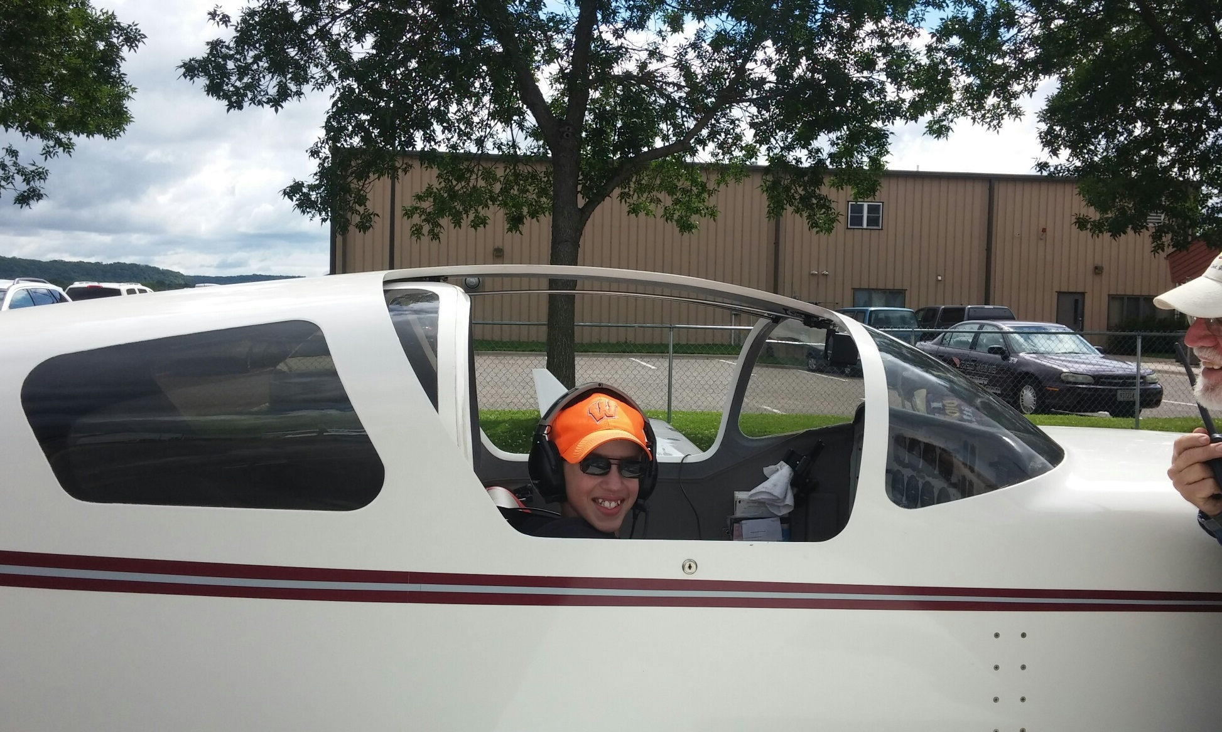

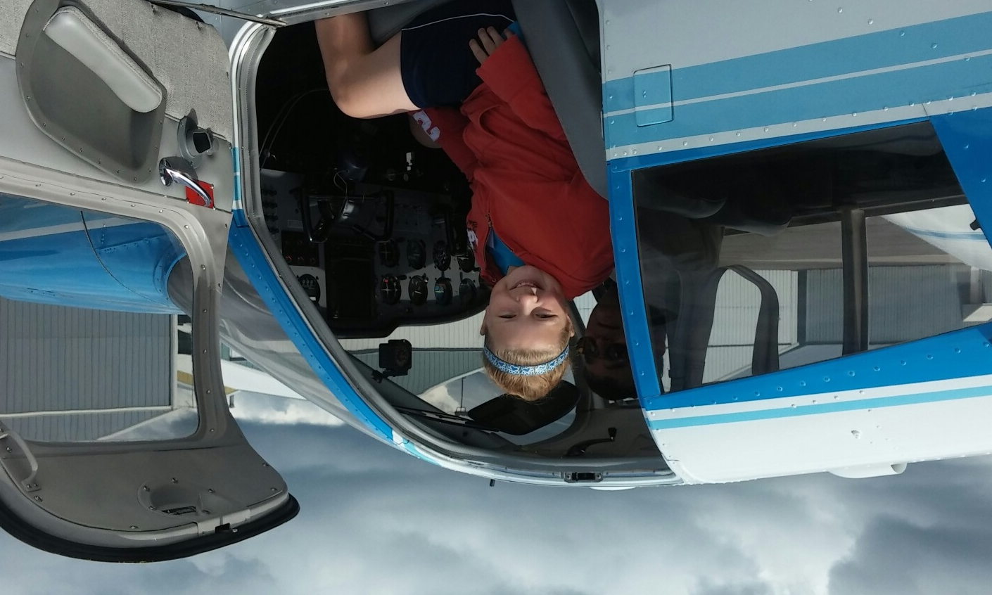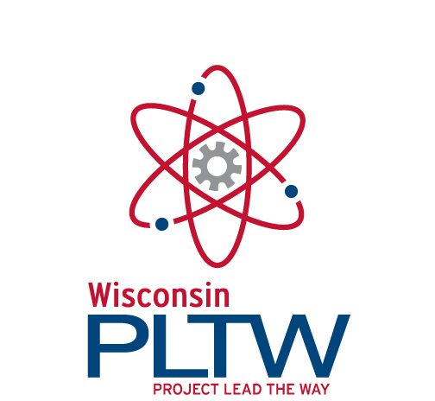**About UW-Extension-Pierce County 4-H**

Children and youth build leadership skills, gain life skills, and explore careers through 4-H projects. Over 900 youth are members of 4-H in Pierce County. The 4-H Gateway Academy is a partnership which involves 4-H activities along with the development of hands-on, high-tech projects. Visit http://pierce.uwex.edu/4h to learn more about 4-H in Pierce County.

**About the SME Education Foundation**

**The Society of Manufacturing Engineers**

(SME) Education Foundation advances manufacturing education through youth programs and scholarships. Science, Technology, and Engineering Preview Summer (STEPS) Academy, now Gateway Academy, was created in an effort to fill the pipeline with skilled manufacturing workers. Visit [www.sme.org/foundation](http://www.sme.org/foundation) for more info.

**About Project Lead the Way (PLTW)**

****Project Lead the Way (PLTW) is a non-profit organization that provides pre-engineering curriculum for middle and high school students. Its Gateway to Technology program is the basis for the Gateway Academy. PLTW is in more than 2,000 schools in 40 states and the District of Columbia, educating more than 175,000 students. Learn more at [www.pltw.org](http://www.pltw.org).

**4-H Gateway Academy:**

A Science, Engineering, Technology & Math Experience for Youth

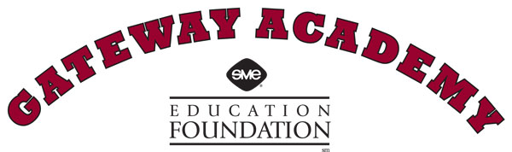



**July 11-15, 2016**

**8:30 AM to 3:00 PM**

**River Falls High School Room D102**

**To Register:**

*Send in registration form, along with $100.00 fee for a one week camp. Enrollment is limited.*

The 4-H Gateway Academy has instructors certified to teach this day camp. They will provide expert instruction in small group settings. During the week, campers will work together in a fun, exciting environment using leading-edge technologies to sample such disciplines as robotics, aeronautics, and computer design.

**4-H GATEWAY ACADEMY APPLICANTS MUST BE:**

* Boys or girls entering 6th, 7th, or 8th grade in the fall of 2016.
* Interested in science, technology, engineering or math careers.
* Comfortable working in a fast-paced environment.
* Curious about how things work.
* Willing to participate in the activities and the field trip.
* Eager to have fun, learn something new, and make new friends.

***The 4-H Gateway Academy*** *is a joint venture of*

*University of Wisconsin-Extension, the Society of Manufacturing Engineers (SME) Education Foundation, and River Falls School District*

**4-H GATEWAY REGISTRATION**

Day Campers will be selected on a first-come, first-serve basis (limited to first 20) by completing the registration in this brochure and payment of a non-refundable $100.00 fee, which includes a t-shirt, field trip, lunches, and all classroom materials for the week. *A portion of fee may be refunded if additional Academy funding is obtained.*

**For additional information please contact:**

**Frank Ginther, 4-H Youth Development Agent,** [**francis.ginther@ces.uwex.edu**](mailto:francis.ginther@ces.uwex.edu) **or 715-273-6781.**

**Registration for Pierce County 4-H Gateway Academy**

**Student Name**

First:

Last:

Grade: (2016-17 school year)

**Address**

Street:

City/Zip:

**Parent or Guardian Name**:

Home Phone:

Cell Phone:

E-mail:

##### Media Release (please check one)

##### ___ I grant permission

##### ___ I do not grant permission

I grant the University of Wisconsin Board of Regents, University of Wisconsin Extension and River Falls School District and agents unlimited permission to copyright and use, publish, and republish for purposes of advertising, public relations, trade or any other lawful use, information about my child’s participation in this program and reproductions (photographic or otherwise) of my child’s voice, likeness and any related creative works produced.

I have read all statements above and fully understand the contents. This release and contract shall be binding upon me and my legal representatives.

Parent or Guardian Printed Name

Parent or Guardian Signature and Date

Send completed registration form & check to: Pierce County UW-Extension

412 West Kinne Street

Ellsworth, WI 54011-0069

Make check payable to:

Pierce County 4-H Adult Advisors

T-Shirt Size – Circle Below –

Youth Large Adult Small Adult Med.

Adult Large Adult XL